**DAILY ONLINE ACTIVITIES SUMMARY**

|  |  |  |  |  |  |  |  |  |
| --- | --- | --- | --- | --- | --- | --- | --- | --- |
| **Date:** | **21/05/2020** | | | | | **Name:** | **JASLINE SHARON TAURO** | |
| **Sem & Sec** | **4th sem, A Section** | | | | | **USN:** | **4AL18CS029** | |
| **Online Test Summary** | | | | | | | | |
| **Subject** | | **MICROCONTROLLER AND EMBEDDED SYSTEMS** | | | | | | |
| **Max. Marks** | | **30** | | **Score** | | | **23** | |
| **Certification Course Summary** | | | | | | | | |
| **Course** | 1. **STEPathon-communication skills [ICT ACEDAMY]** | | | | | | | |
| **Certificate Provider** | | | **1.THE HINDU** | | **Duration:**  **1.2 hrs.** | | |  |
| **Coding Challenges** | | | | | | | | |
| **Problem Statement: 1. Write a C program to implement SRTF process scheduling.**  **2. Write a C program to construct a singly linked list by removing duplicate elements in the sorted linked list** | | | | | | | | |
| **Status: DONE** | | | | | | | | |
| **Uploaded the report in GitHub** | | | | | **YES** | | | |
| **If yes Repository name** | | | | | [**https://github.com/jaslinesharontauro/C_Prgms**](https://github.com/jaslinesharontauro/C_Prgms) | | | |
| **Uploaded the report in slack** | | | | | **YES** | | | |

**Online Test Details: (Attach the snapshot and briefly write the report for the same)**

**Certification Course Details: (Attach the snapshot and briefly write the report for the same)**

**Coding Challenges Details: (Attach the snapshot and briefly write the report for the same)**

**1.ONLINE TEST DETAILS:**

**Today we had assessment in the subject MICROCONTROLLER AND EMBEDDED SYSTEM. It was based on first module of this subject. There were total 30 number of questions of ONE mark each.**

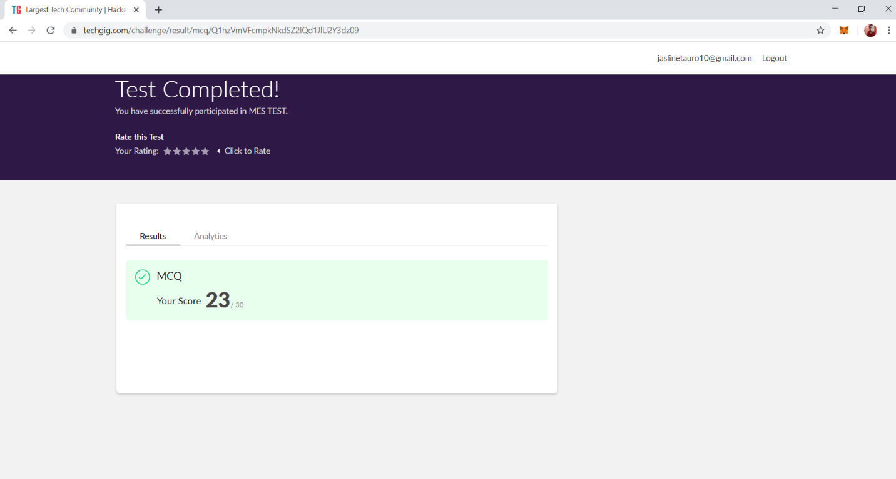

**2.CERTIFICATION COURSE DETAILS:**

**Today I have done 2 certification courses**

* **STEPathon-communication skills [ICT ACEDAMY]:**

**This course based on communication skills. Today I have completed the 9 videos. The videos were based on listening, Reading, Writing and Grammar skills.**

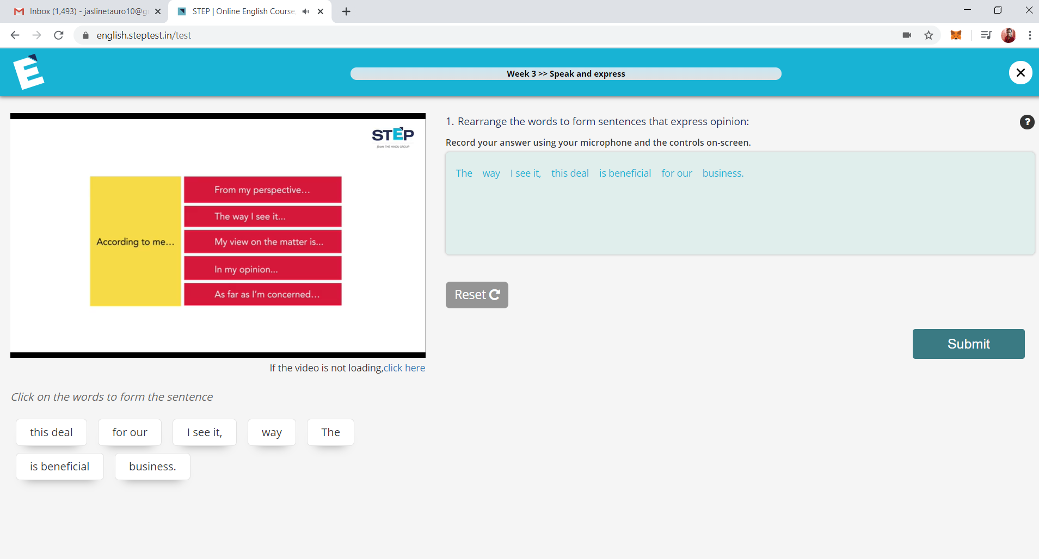

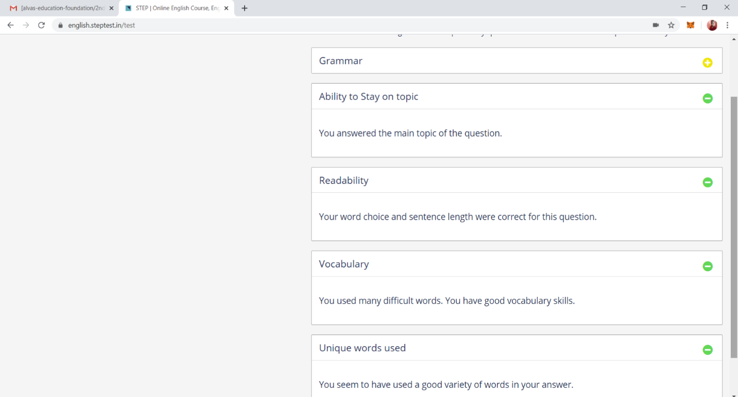

**3.CODING CHALLENGES DETAILS:**

**Problem statement 1: Write a C program to implement SRTF process scheduling.  
Input: A set of processes with their burst time and arrival time  
Output: The processes scheduled based on the arrival time and a smaller burst time.**

**Solution: Uploaded it in GitHub**

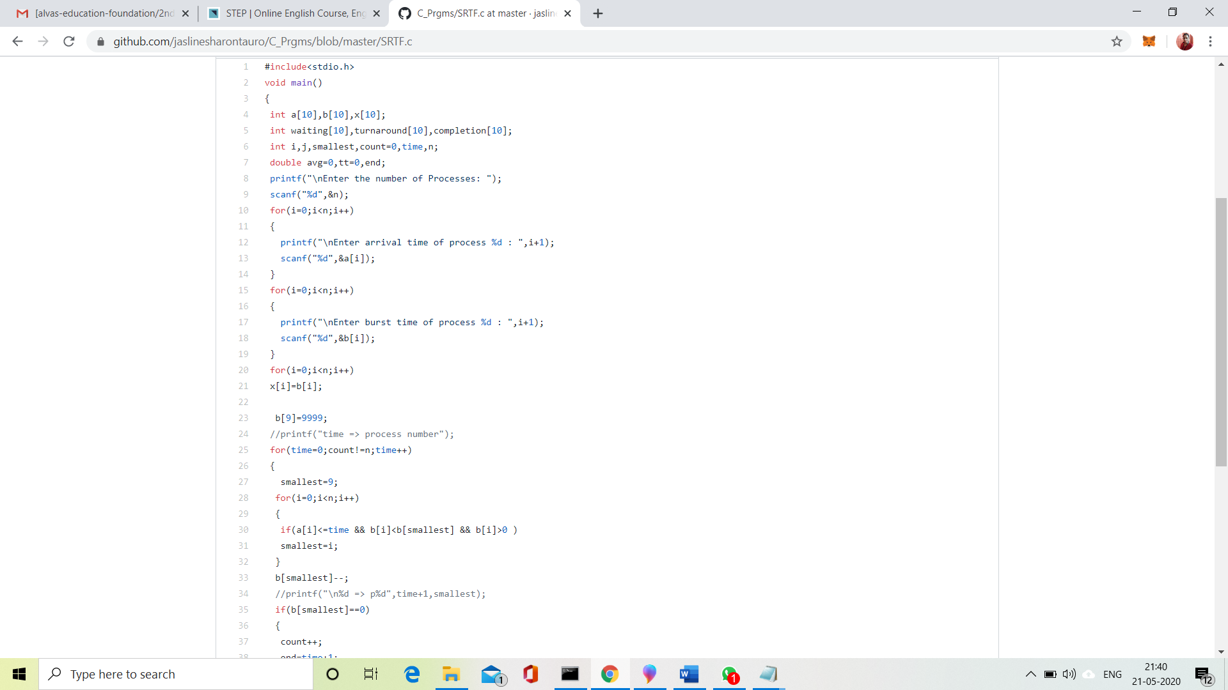

**Problem statement 2:**

**Write a C program to construct a singly linked list by removing duplicate elements in the sorted linked list  
Description:  
Take a sorted list and traverse the list. Compare the current node element with next adjacent node. If it is same then delete second element, if not retain. Finally print the resulting list.  
Sample output:  
Given list {1,2,2,3,3,3,4}  
Resulting list {1,2,3,4}**

**Solution: Uploaded it in GitHub**

